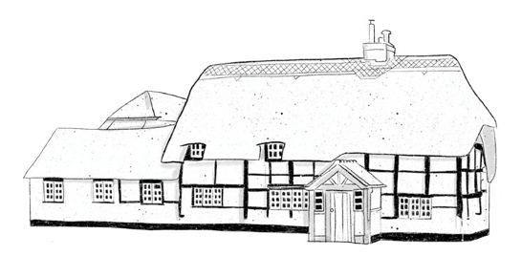

T I P I

Breakfast

Sausage Brioche Bun 6.5 + fried egg 1
Bacon Brioche Bun 6.5 + fried egg 1

Pizzas

Margherita, tomato base, mozzarella & fresh basil £12 (V)

Spicy N’duja, pepperoni, tomato base & mozzarella £14

Venison, tomato base & mozzarella £14

BBQ pulled pork sub
Toasted brioche bun, pulled bork marinated in BBQ sauce, melted Oxfordshire cheddar, pickled slaw & parsley £15.50

KIDS

Cheese & Tomato Pizza £6 (V)

Pepperoni Pizza £8

Soft drinks
Coke / Diet Coke 3.7/3.5
Sprite 3.7
Appletiser 3.7
Fentimans Ginger Beer 4.0
Hartridges Orange & Passionfruit /
Apple & Raspberry/ Apple & Mango 3.7
Apple Juice / Orange Juice / Pineapple Juice
Tomato Juice/ Cranberry Juice 3
Elderflower spritz 4
Fever Tree; Ginger Ale/ Tonic/ Slim Tonic
Elderflower Tonic / Mediterranean Tonic
Lemon Tonic/ Soda Water/ Lemonade 2.8

White 125ml 175ml 250ml
Viertalo, Sauvignon Blanc, Airen, Spain 5 7 10
Pinot Grigio, Prima Alta, Veneto, Italy 5.5 7.5 11
Lua Nova, Vinho Verde, Portugal Vegan 5.5 7.5 11
Isabel Estate Sauvignon Blanc, Marlborough, New Zealand 8 12 16
Macon-Villages, Florieres, Burgundy, France 11 16.5 22
Red 125ml 175ml 250ml
Viertalo, Tempranillo, Garnacha, Spain 5 7 10
Soli, Merlot, Thracian Valley, South Bulgaria 5.5 7.5 11
Beaujolais Vielles Vignes, Domaine de la Rocaillere, France 7 9 14
Passitivo, Primativo Appassimmento, Puglia, Italy 7 10 14
Azabache Reseerva, Rioja, Spain 7.5 10.5 15
Luigi Bosca Malbec DOC, Mendoza, Argentina 8 10.5 16
Rosé 125ml 175ml 250ml
Les Turitelles d’Altugnac Origines, Languedoc, France 5.5 7.5 11
Mirabeau X, Cote de Provence, France 6.5 9.5 13
Bubbles
Vaporetto Prosecco, Veneto, Italy, NV 6.5 - -

Nicolas Courtin Champagne, Oiry, France. NV 12 - -

Kingwood Cuvee Brut, Henley-on-Thames, 2018 13 - -

Beer Pint 330ml
Estrella Damm, Barcelona, Spain 4.6% 6.0
BumbleBee Cider, Strawberry Mojito 4.0% 6.3
Rebellion Lager, Marlow, 4.4% 6.8
Renegade Master Lager, Yattendon 5.1% 6.9

Kicking Goat Craft Cider, Goring, 4.5% 6.1
Guinness, Dublin 4.1% 6.7
Rebellion IPA, Marlow 3.4% 5.2
Detour Pale Ale, Yattendon 4.1% 6.5
Hocus Pocus, Loddon Brewery 5.6% 5.5
Doombar 4.3% 6.9 (500ml bottle)
No or Low 330ml
Heineken 0.0 alcohol free lager 0% 4.5
Doombar 0% 6.7 (500ml bottle)

Gin 25ml 50ml

Hendricks Gin, Scotland 4.5 9
Martin Millers, Iceland 5 10
The Henley Gin, London dry, Henley 5 10
The Henley Gin Orange & rhubarb, Henley 5.5 11
Thr Henley Oriental spiced, Henley 5.5 11
B&G Coppid blend, Binfield Heath 5.5 11
Sipsmith London Dry, London 5 10
Aviation Gin, America 6 12
Silverback Old Tom, Basingstoke 6 12
Monkey 47, Germany 8.5 17

No or Low
Seedlip Garden 108 5 10
Seedlip Aromatic Spiced 94 5 10

